Contract Correspondence Transmittal (CCT)

CCT Number: 20-06 Date of Issue: 4/14/2020
Issuance: Division of Protection and Permanency, Mary Carpenter Assistant Director MC
Key Words/Phrases: KY TWIST Payments portal, electronic remittance statements
Attachments/Forms: KY TWIST Payments-Organization User Guide

The intent of this correspondence is to provide information concerning the new KY TWIST Payments portal. This portal will enable PCC’s and PCP’s to review and print their detailed remittance statements for their payments. Remittance statements will no longer be sent through the mail.

The electronic remittance statements will be accessed through the KY TWIST Payments portal on the Kentucky Online Gateway (KOG). An invitation will be sent through the KOG to the Provider’s identified billing personnel. Once the invitation has been received, the directions below will enable the Provider to access the electronic remittance statements.

If you have additional questions, please contact the below:

Jennifer Blair, Child Welfare Fiscal Services Branch Manager
Division of Administrative & Financial Management (DAFM)
Jennifer.Blair@ky.gov

Lisa Wise-Hodnett, DAFM
Lisa.Wise-Hodnett@ky.gov

Accepting An Invitation
When an invitation is received, the user will open the email in their browser and click the link. When the link is clicked, the user will be taken to the KOG Log in page.

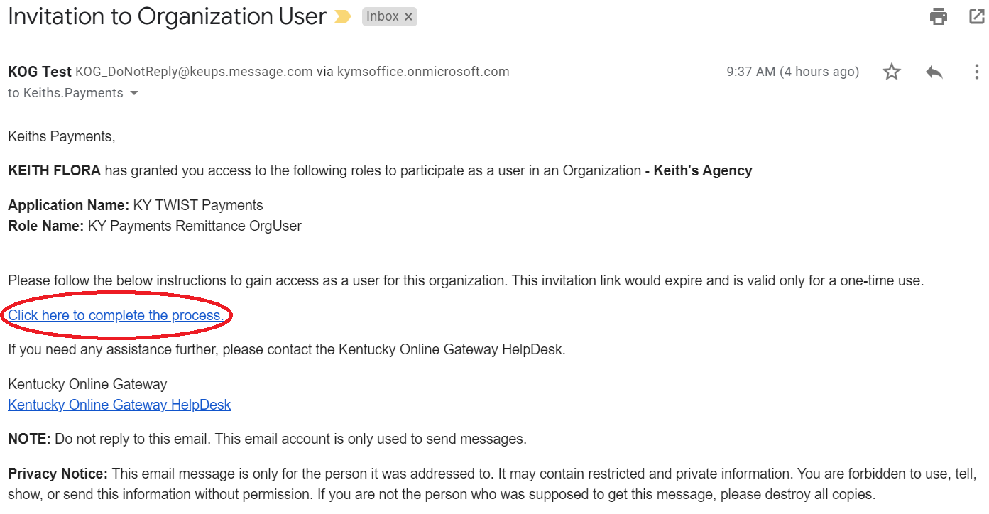

If the user already has a KOG Account, they can log in and see the KY TWIST Payments application in their list of available application. If the user is new to KOG, they will need to create an account by clicking the “Create An Account” button.

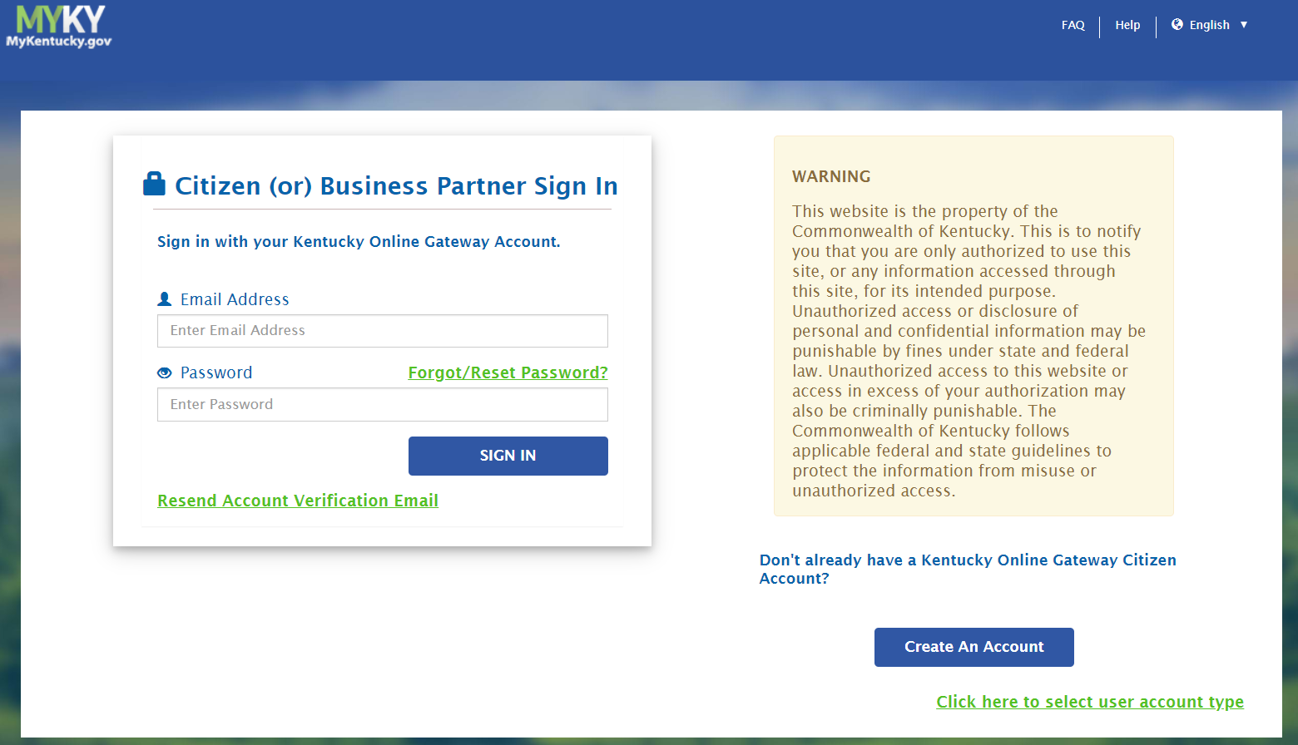

The required fields are designated by the red * next to the label. At the bottom of the screen, make sure to pick questions and answers that you can easily remember. These will be used to reset your password if it is forgotten.

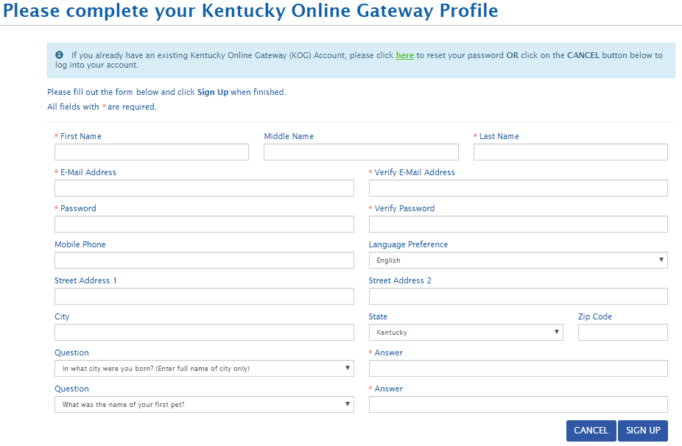

When the user clicks Sign Up, they will see a confirmation message that an email has been sent. The user will need to open the email message and click the link to complete the registration process.

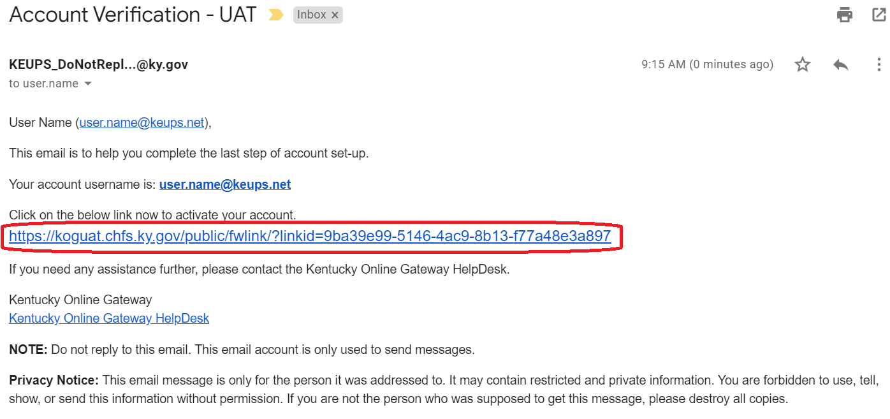

The user will see the Validate New Account screen. To complete the account create, the user will click the “Continue to Sign in” button.
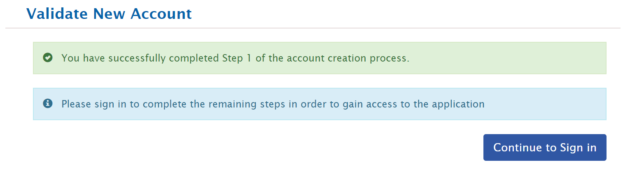

This will return the user to the KOG Login screen where they will enter the email address and password they entered during Account Creation.

The user may or may not get the below screen to confirm the request. If so, click the Submit Request button.

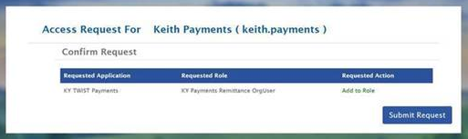

Access KY TWIST Payments
Once logged in the KY TWIST Payments application widget will be listed along with any other applications to which the user has access. To review remittance statements, click the Launch button on the KY TWIST Payments widget.

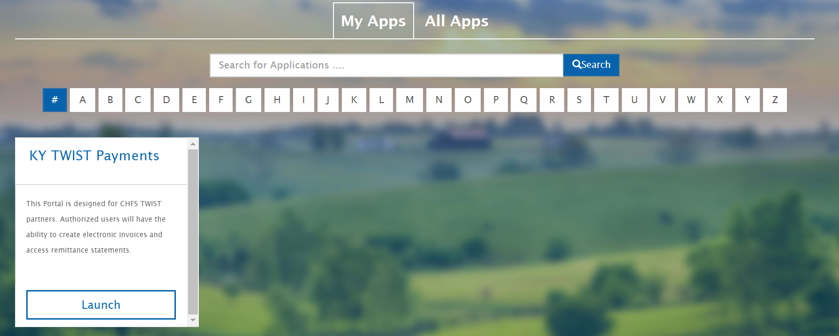

Click the Remittance menu at the top of the page.

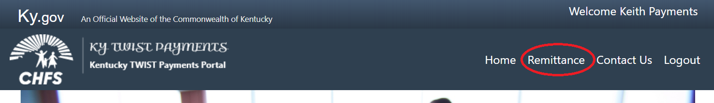

By Default, the last 3 months worth of remittance statements will show in the results grid. To see older statements, change the From Date accordingly. Click view to see the remittance statement. Depending on your internet browser settings, the remittance statements will either open in the browser or in your pdf viewer.



